

A PROJECT REPORT ON

**CHEM STOCKS**

SUBMITTED

BY

Shalini GaundSEAT NO.________

Sandya Bala SEAT NO.________

(T.Y.B.Sc I.T)

ACADEMIC YEAR 2018-2019

UNDER THE GUIDANCE OF

**MRS. R. ARUDSELVI**

A PROJECT REPORT

ON

CHEM STOCK

SUBMITTED

BY

**SHALINI GAUND**

**SANDYA BALA**

ACADEMIC YEAR 2018-2019

UNDER THE GUIDANCE

OF

**MRS. R. ARUDSELVI**

SUBMITTED

TO

**UNIVERSITY OF MUMBAI**

DEPARTMENT OF INFORMATION TECHNOLOGY

GURU NANAK COLLEGE OF ARTS, SCIENCE & COMMERCE

G.T.B. NAGAR MUMBAI – 400037



**CERTIFICATE**

This is to certify that project **CHEM STOCK** is a bonafide work done by Mr. /Ms. _________________________Seat no._________ in partial fulfillment of B.Sc. I.T. degree (Semester V) examination had not been submitted for any other examination and does not form part of any other course undergone by the candidate.

It is further certified that he/she has completed all required phases of the project.

_______________ _______________

Project Guide Head of BSc.(IT) department

_______________ _______________

Internal Examiner External Examiner

Date:___________ College Stamp

**ABSTRACT**

The system that we use provides all the necessary information with regard to the chemicals we purchase, all we need from the laboratory is; the date of the chemical was received (incremented). The date of the chemical containers was emptied (decremented). The labeling system (code) has to be a campus standard, easy to use and consistently applied, and the labels must be suitable for the environment. A single person could be able to monitor, track the stocks of chemicals available in the lab. If any stock of chemical is less in number then we will get notified.

**ACKNOWLEDGEMENT**

We thank the almighty for giving us the courage and perseverance in completing the project. This project itself is an acknowledgement for all those who have given us their heart felt co-operation in making it a grand success.

We would like to express our deep gratitude to our honourable principal Dr.Vijay Dabholkar for giving us an opportunity to study and pursue a career in Information Technology

I would like to express my appreciation to our Head of the department and my project guide Mrs. R.Arudselvi for her valuable and constructive suggestions during the planning and development of this project work.

A Special thanks to all our professors of Information Technology for their valuable advises at every stages of work. Also we are extending our thanks to lab assistants and admins for their seemingly small but valuable help for timely Internet Access and Lab Access

Last but not least, we would like to express our deep sense and earnest thanks to our dear parents for their moral support, strength and help for everything.

**INDEX**

|  |  |  |
| --- | --- | --- |
| Sr.no. | Topic | Page No. |
| 1 | Introduction  1.1 Objectives  1.2 Purpose, Scope, and Applicability  1.2.1 Purpose  1.2.2 Scope  1.2.3 Applicability  1.2.4 Organization of report |  |
| 2 | **SURVEY OF TECHNOLOGIES**  2.1 Literature Survey  2.2 Existing System and its limitations  2.3 Proposed System and its advantages |  |
| 3 | **REQUIREMENTS AND ANALYSIS**  3.1 Problem Definition  3.2 Requirements Specification  3.3 Planning and Scheduling (Gantt chart & PERT Chart)  3.4 Software and Hardware Requirements |  |
| 4 | **SYSTEM DESIGN**  4.1 Basic Modules  4.2 Data Design  4.2.1 Architecture Design  4.2.2 Schema Design(ER Diagram)  4.3 UML Design  4.3.1 Use case Diagram  4.3.2 Class Diagram  4.3.3 State Diagram  4.3.4 Collaboration Diagram  4.3.5 Sequence Diagram  4.3.6 State Diagram  4.4 User interface design (sample design of Output screen)  4.5 Test Cases Design |  |

**TABLE OF FIGURES**

|  |  |  |
| --- | --- | --- |
| **FIG.** **NO** | **FIGURE** | **Pg.No.** |
| **DATA DESIGN** | | |
| 1 | Architecture Design |  |
| 2 | Schema Design |  |
| **UML DIAGRAMS** | | |
| 3 | Use Case Diagram of ENTIR SYSTEM |  |
| 4 | Use case Diagram For LOGIN,REGISTRATION |  |
| 5 | Use case Diagram For STATUS,CART |  |
| 6 | Class Diagram-1 |  |
| 7 | Class Diagram-2 |  |
| 8 | Class Diagram-3 |  |
| 9 | Activity Diagram Of User |  |
| 10 | Activity Diagram For Admin |  |
| 11 | Activity Diagram For System |  |
| 12 | Collaboration Diagram of LOGIN |  |
| 13 | Collaboration Diagram For System |  |
| 14 | Collaboration Diagram For CART |  |
| 15 | Sequence Diagram of Login |  |
| 16 | Sequence Diagram for Chart |  |
| 17 | Sequence Diagram for Chemical Details |  |
| 18 | State Diagram For User/Admin |  |
| 19 | State Diagram For Sever |  |

**CHAPTER 1**

**INTRODUCTION**

* 1. **Objectives**

1. **To supply the required materials continuously**: There should be a continuous available of chemicals in the laboratory. The main objective of the software is to maintain required chemicals so that production and sales process run smoothly.
2. **To minimize the risk of under stocking of chemicals:**If there is no track of chemicals available in the laboratory without proper analysis, there will be a chance of understocking. So one of the main objectives of the software is to minimize the risk caused due to under stocking of chemicals.And alsothere is a need to keep maximum stock of material since maximum requirement may arise at any time.
3. **To maintain systematic record of Chemicals:** A systematic records of stocks helps us to provide information about the availability of the chemicals. It also assists to evaluate the current inventory management policy.

**1.2 Purpose, Scope, and Applicability**

**1.2.1. Purpose**

* **Protect against stockout**

One reason for carrying inventory is that goods cannot arrive immediately when you run out of stock. A certain amount of lead time is needed for goods to be produced and delivered. You have to make sure that you have enough inventory in stock to cover demand during the period of lead time.The result is the need to carry inventory to protect against possible stockouts.

* **Maintain Record**

Lab supplies are not the only thing you should be keeping close track of. Maintaining good records and ensuring safe storage is key to running a productive lab.

**1.2.2. Scope**

1. Manual work is decreased and a proper record of stocks is maintained.
2. A good maintenance of chemical stocks may not lead to under stocking.
3. This enables the user to track details of availability of stocks present so that they use this information for further ordering process.
4. There will be records of activities which are performed such as adding or removing of chemicals in the laboratory.

**1.2.3 Applicability**

1. A single person could be able to monitor, track the stocks of chemicals available in the lab.
2. If any stock of chemical is less in number then we will get notified.
3. It will save time of managing stocks of chemicals.

**1.2.4 Organization of report**

The further chapters discuss and give a more detailed description about the project.

**CHAPTER 2**

**SURVEY OF TECHNOLOGIES**

**2.1 Literature Survey**

* There is a wide range of existing software available today so we have gathered some ideas from that for our software. Example:- ZOHO is one of the inventory management software.
* The similar software is used for huge organizations where research works are conducted.
* The software for small laboratories are limited so through this software we can implement it in small environment.

**2.2 Existing System and its limitations**

* Existing Software is used to managing the stocks of chemicals in huge organizations.
* There is a barcode system where they need to give barcode to every and each bottle of chemical.
* But,in Laboratory, again and again they need to check the availability of chemical stock.
* Manual work is more.

**Limitation:**

* The existing System is not useful for small laboratories.

**2.3 Proposed System and its advantages**

* This system is used for chemical stocking.
* Reporting the details of chemical.
* All the buying and removing date are displayed.
* No barcode system , only the user need to enter the code or name of chemical in the system.

Advantages:

* It will notify when any chemical stock is less.
* The user name who is taking out the number of chemical stock.
* Manual work and time is reduced.
* The chemicals which are removed can be sorted on the basis of specific date or month according to the user.

**CHAPTER 3**

**REQUIREMENTS AND ANALYSIS**

* 1. **Problem Definition:**
* There was lack of maintenance of chemical stock available in the chemistry lab.
* Due to which at some sort of time student won’t be able to do practicals.
* The lab assistant manager did not get the idea to maintain the stock so that it will not create problem.
  1. **Requirements Specification**
* This system will manage all the stocks available as well as it have record of chemical purchasing date
* It will have all the detail of in and out of chemical stocks.
* Chemicals can be added to cart.
* If any stock of chemical is less in number then we will get notified.
  1. **Planning and Scheduling (Gantt chart & PERT Chart)**

Gantt chart:

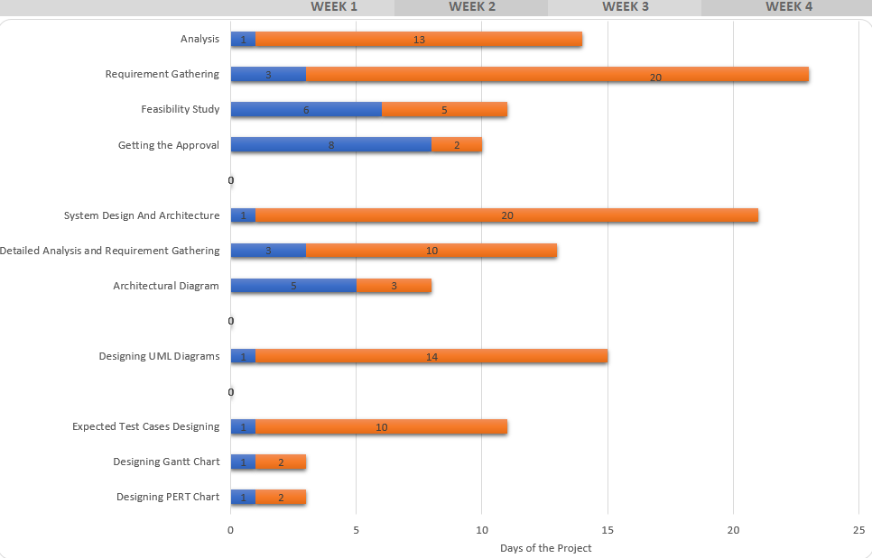

**PERT CHART:**

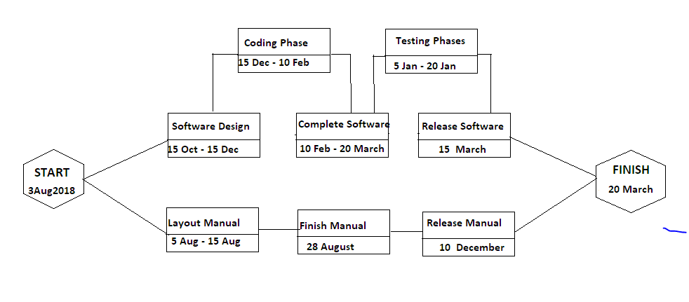

**3.4.**  **Software and Hardware Requirements**

**Server-side hardware and software requirement**

**Hardware:**

* Processor-1.0 GHz
* HardDisk -20 GB
* Memory-2 GB

**Software:**

* Windows 7 or higher version
* Microsoft visual Studio 2010
* Ms SQL server 2008

Client-side hardware and software requirement

**Hardware:**

* Processor-1.0 GHz
* Hard Disk -20 GB
* Memory-2 GB

**Software:**

* Webserver

**CHAPTER 4**

**SYSTEM DESIGN**

**4.1. Basic Modules**

* Home-Here admin, User login and registration will be there. The admin can add user and change password . About us is also there . Here we can also choose forgot password.
* Chemical details-This shows the details about the chemicals name , Quantity and its availability.In this we can insert,update,delete, and buying history of specific chemical can be displayed using search. Purchase record shows the buying date of chemical.
* Status-the chemical which are less is displayed and can be added to cart.
* Cart-the chemicals which are there in cart can be export to excel sheet.
* History of User- The chemicals which are removed will be displayed and can be sorted in months or date. User name who is removed the chemicals and its quantity.
* Requirement based on courses-Quantity of each chemical required for different courses.
* System Logout-logout from the software

**4.2. Data Design**

**4.2.1 Architecture Design**

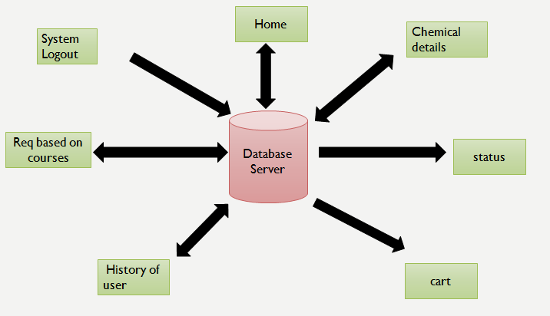

**4.2.2 Schema Design(ER Diagram)**

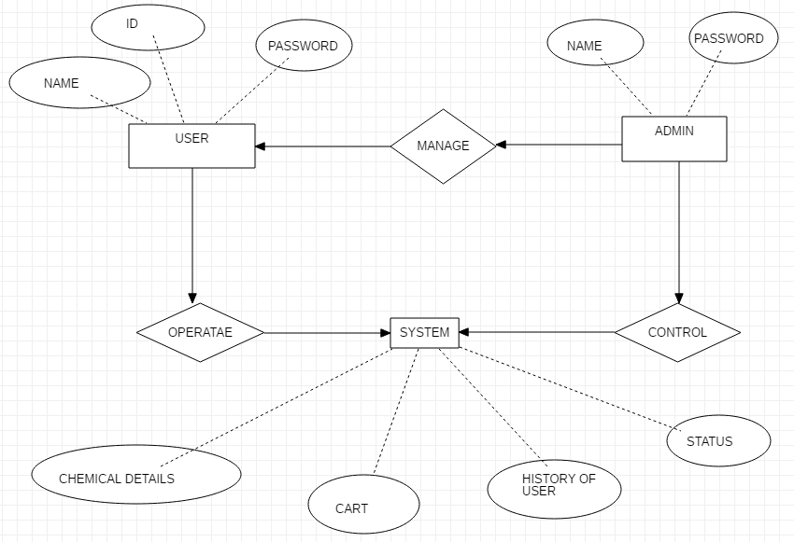

**4.3. UML Design**

**4.3.1 USE CASE DIAGRAM**

* A **use case diagram** at its simplest is a representation of a user's interaction with the system that shows the relationship between the user and the different use cases in which the user is involved.
* These diagrams present a high level view of how the system is used as viewed from an outsider’s (actor’s)perspective.  A use case diagram contains four components.
* The boundary, which defines the system of interest in relation to the world around it.
* The actors, usually individuals involved with the system defined according to their roles.
* The use cases, which are the specific roles played by the actors within and around the system.

The relationships between and among the actors and the use cases.

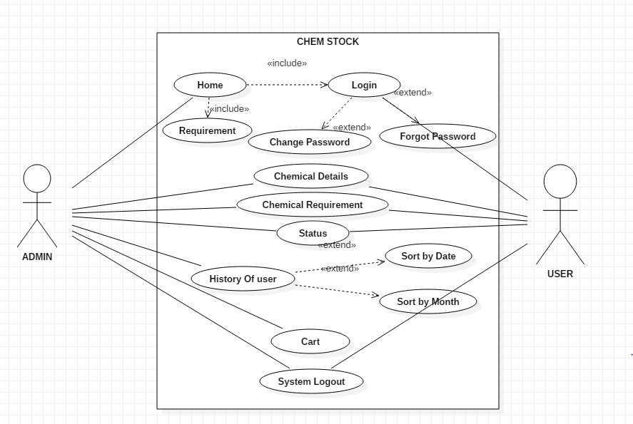

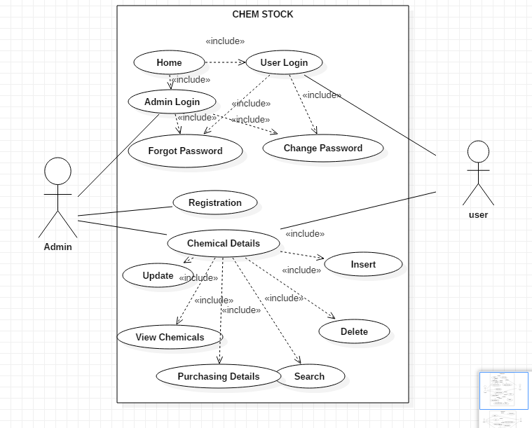

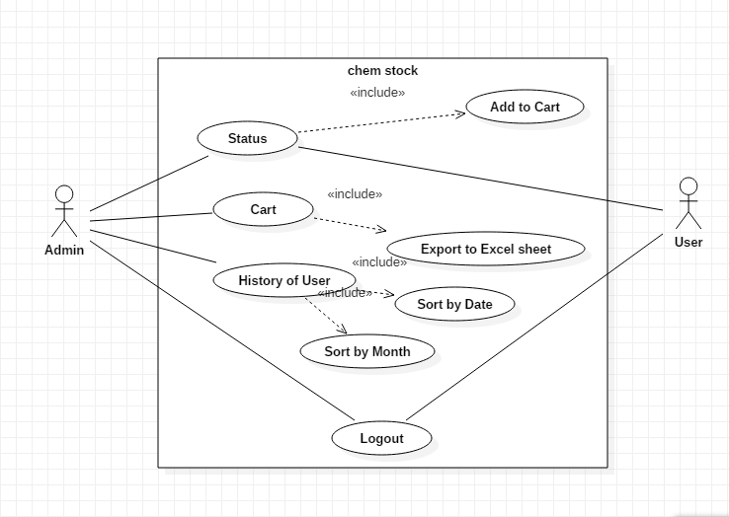

**4.3.3 CLASS DIAGRAM**

* In software engineering, a **class diagram** in the Unified Modelling Language (UML) is a type of static structure diagram that describes the structure of a system by showing the system's classes, their attributes, operations (or methods), and the relationships among objects.
* In the diagram, classes are represented with boxes that contain three compartments:
* The top compartment contains the name of the class. It is printed in bold and centred, and the first letter is capitalized.
* The bottom compartment contains the operations the class can execute. They are also left-aligned and the first letter is lowercase
* **Member access modifiers**
  + All classes have different access levels depending on the access modifier (visibility). Here are the access levels with their corresponding symbols:
  + Public (+)
  + Private (-)
  + Protected (#)

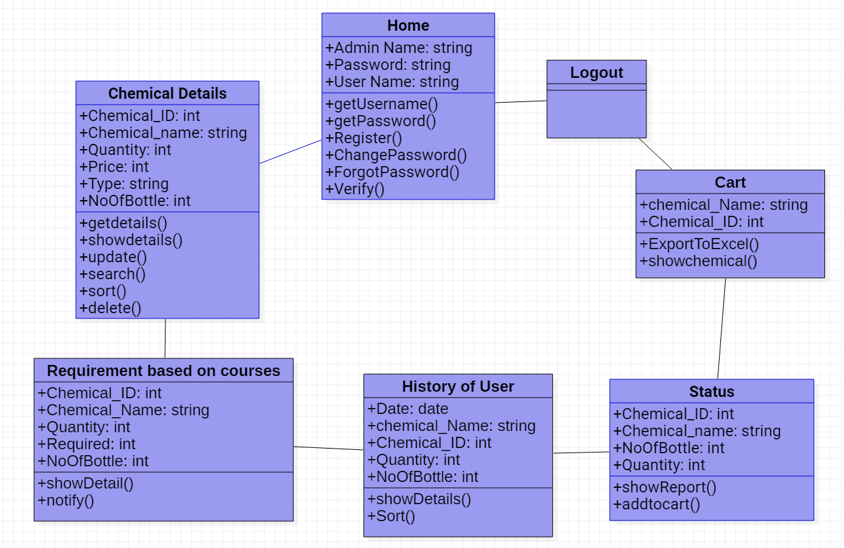

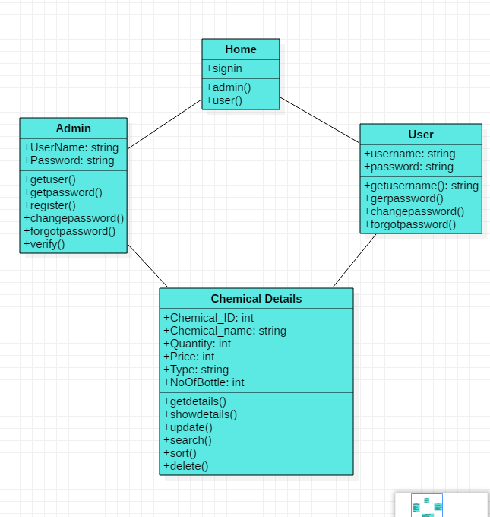

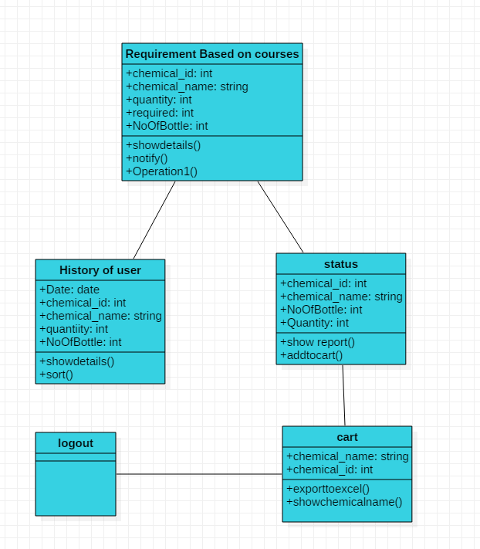

**4.3.3 Activity Diagram**

* Activity diagram is another important diagram in UML to describe the dynamic aspects of the system. Activity diagram is basically a flowchart to represent the flow from one activity to another activity.
* **Action:** A step in the activity wherein the users or software perform a given task.
* **Forks and Joins:** A fork construct is used to model a single flows. A join consists of two or more flows of control that unite into a single flow of control.
* **Decision node**: A conditional branch in the flow that is represented by a diamond. It includes a single input and two or more outputs.
* **Control flows:** Another name for the connectors that show the flow between steps in the diagram.
* **Start node:** Symbolizes the beginning of the activity. The start node is represented by a black circle.
* **End node:** Represents the final step in the activity. The end node is represented by an outlined black circle.

**ACTIVITY diagram – USER**

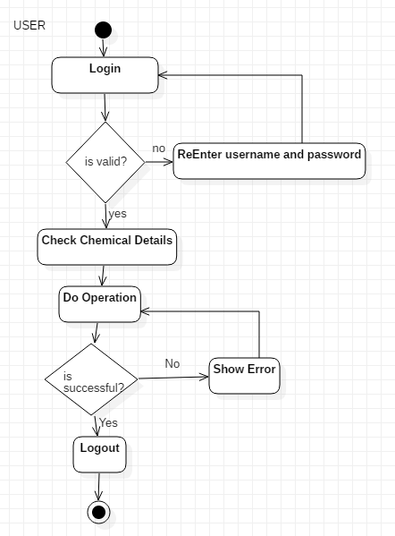

**ACTIVITY diagram – ADMIN**

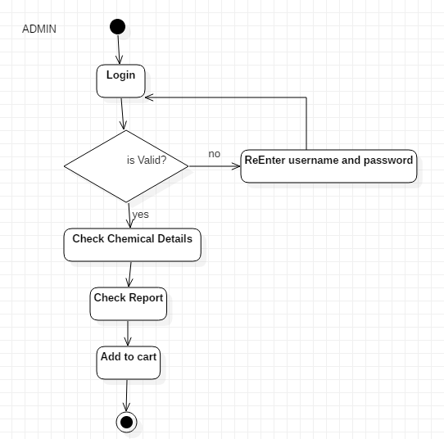

**ACTIVITY diagram –system**

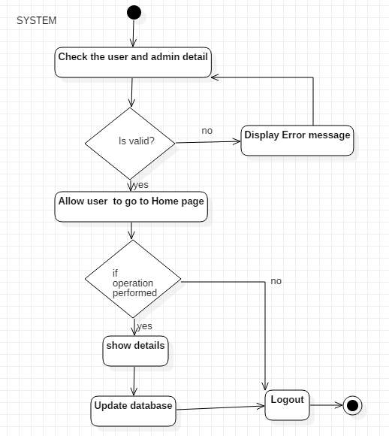

**4.3.4 COLLABORATION DIAGRAM**

* Collaboration diagrams are used to show how objects interact to perform the behaviour of a particular use case, or a part of a use case. Along with sequence diagrams, collaborations are used by designers to define and clarify the roles of the objects that perform a particular flow of events of a use case. They are the primary source of information used to determining class responsibilities and interfaces.
* You can have objects and actor instances in collaboration diagrams, together with links and messages describing how they are related and how they interact.
* Unlike a sequence diagram, a collaboration diagram shows the relationships among the objects. Sequence diagrams and collaboration diagrams express similar information, but show it in different ways. Collaboration diagrams show the relationships among objects and are better for understanding all the effects on a given object and for procedural design.

**Collaboration Diagram of LOGIN**

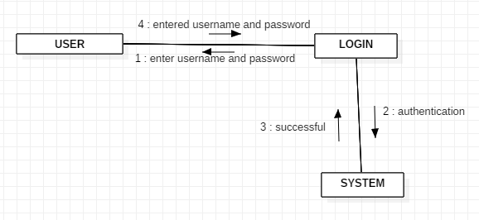

**Collaboration Diagram of CART**

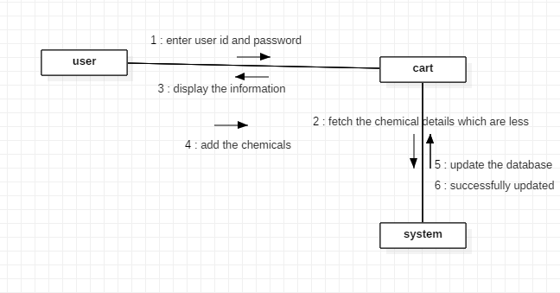

**Collaboration Diagram of CHEMICAL DETAILS**

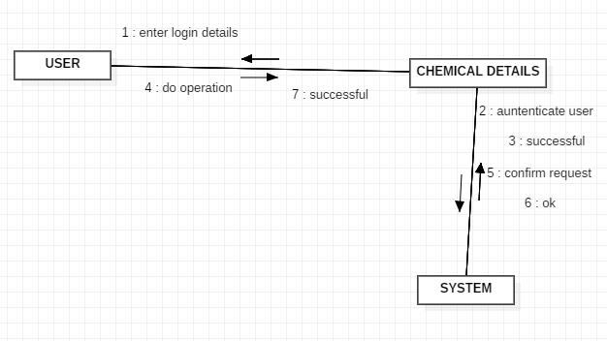

**4.3.5 Sequence Diagram**

* A sequence diagram has two dimensions: the vertical dimension represents time; the horizontal dimension represents different objects. The vertical line is called the object’s lifeline. The lifeline represents the object’s existence during the interaction. The following tools located on the sequence diagram toolbox which enable to model sequence diagrams:
* **Object:**

An object has state, behavior, and identity. The structure and behavior of similar objects are defined in their common class. Each object in a diagram indicates some instance of a class. An object that is not named is referred to as a class instance.

* **Message Icons**

A message icon represents the communication between objects indicating that an action will follow. The message icon is a horizontal, solid arrow connecting two lifelines together.

* **Focus of Control**

Focus of Control (FOC) is an advanced notational technique that enhances sequence diagrams. It shows the period of time during which an object is performing an action, either directly or through an underlying procedure.

* **Message to Self**

A Message to Self is a tool that sends a message from one object back to the same object. It does not involve other objects because the message returns to the same object. The sender of a message is the same as the receiver.

* **Note**

A note captures the assumptions and decisions applied during analysis and design. Notes may contain any information, including plaintext, fragments of code, or references to other documents.

* **Note Anchor**

A note anchor connects a note to the element that it affects.

1. **Sequence diagram-login**

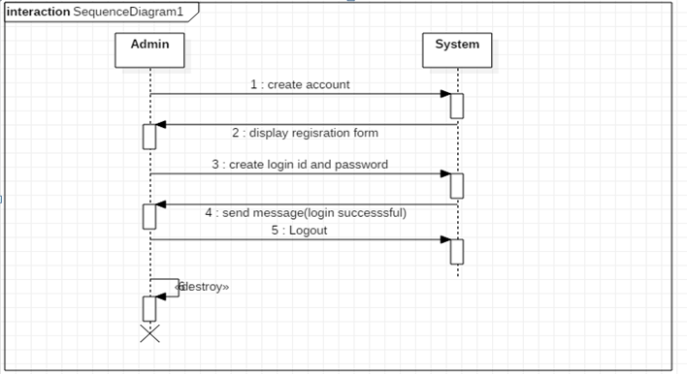

1. **Sequence diagram-cart**

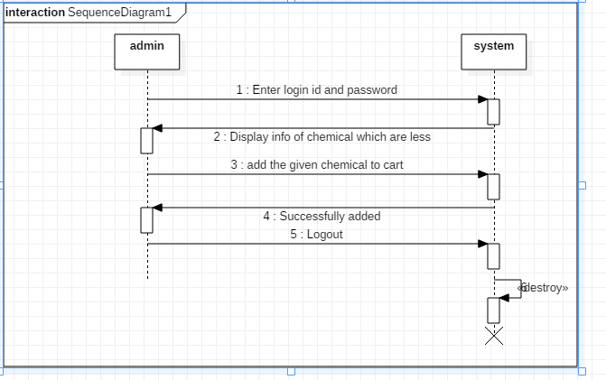

1. **Sequence diagram-chemical details**

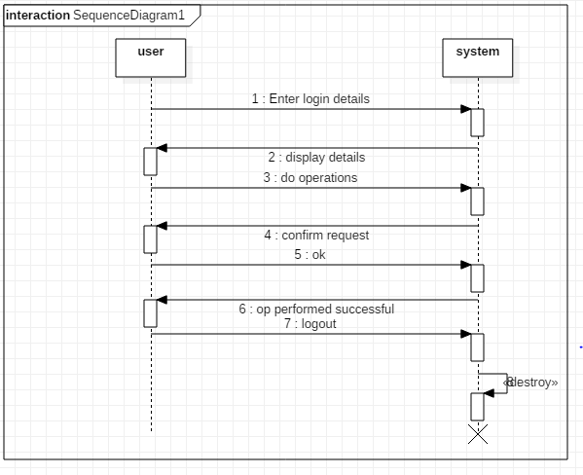

**4.3.6. State Diagram**

* State chart diagrams are closely related to activity diagrams. The main difference between the two diagrams is state chart diagrams are state centric, while activity diagrams are activity centric.
* **Decisions:**

A decision represents a specific location on state chart diagram where the workflow may branch based upon guard conditions.

* **Forks and Joins:**

A fork construct is used to model a single flow of control the divides into two or more separate, but simultaneous flows. A join consists of two of more flows of control that unite into a single flow of control.

* **States:**

A state represents a condition or situation during the life of an object during which it satisfies some condition or waits for some event.

* **Transitions:**

A state transition indicates that an object in the source state will perform certain specified actions and enter the destination state when a specified event occurs or when certain conditions are satisfied.

* **Start State:**

A start state (also called an "initial state") explicitly shows the beginning of a workflow

* **End State:**

An end state represents a final or terminal state.

1. **State Diagram-User/Admin:**

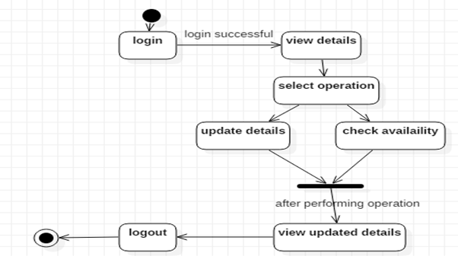

1. **State Diagram-Server:**

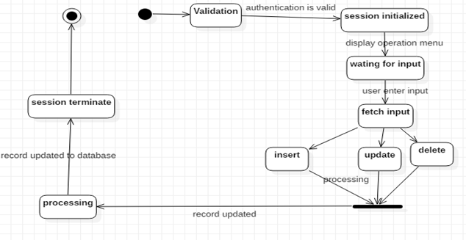

**4.4 User Interface Design (sample design of Output screen)**

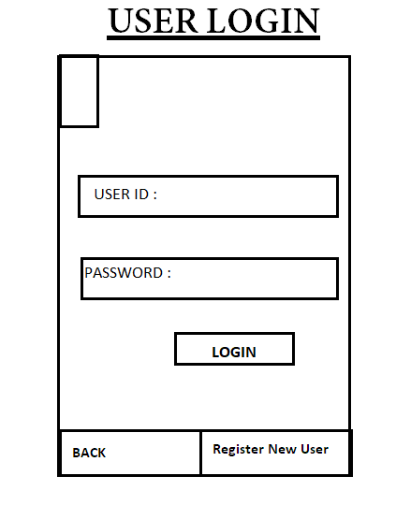

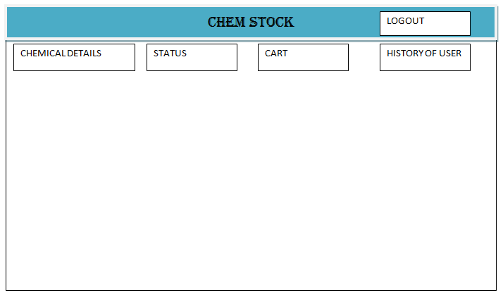

**4.5 Test Cases Design**